**Name:** Rameen **Roll No:** 2023-EE-03

EE-322L Analog and Digital Communication Marks Obtained: ________

**Lab Report**

**Experiment No. 3**

**Auto-correlation and Energy Spectral Density of a deterministic Signal**

**Note:**

* **Don’t forget to include the rubrics table (available at the end in this document), otherwise reports will not be graded.**
* **Copy-pasted and plagiarized reports will get zero marks**

**Ensure proper comments are there in the source code of each task**

**Note:**

* **Don’t forget to include the rubrics tables (available at the end in this document), otherwise reports will not be graded.**
* **Copy-pasted and plagiarized reports will get zero marks**
* **Ensure proper comments are there in the source code of each task**

1. **Objective**

To verify, using MATLAB, that the Energy Spectral Density (ESD) of a deterministic energy signal is equal to the Fourier transform of its autocorrelation. This is done by computing the DTFT of a given finite-length pulse, calculating its ESD, computing the autocorrelation of the same pulse, and then taking its DTFT for comparison.

1. **Technical Background**

An energy signal is a signal with finite total energy. Its frequency content can be analyzed using the Discrete-Time Fourier Transform (DTFT). According to the Wiener–Khinchin theorem, the Energy Spectral Density (ESD) of an energy signal can be obtained in two equivalent ways: either by taking the magnitude-squared of its DTFT, or by taking the Fourier transform of its autocorrelation. If both approaches produce the same spectral result, it confirms the theoretical relationship between ESD and autocorrelation for deterministic energy signals.

1. **Task-1**
   1. ***Description of Task-1***

For the discrete signal:

u[n] = [1, 1, 1, 1, 1]

where n = [-2, -1, 0, 1, 2]

Find **Discrete-Time Fourier Transform** (DTFT) is given by:

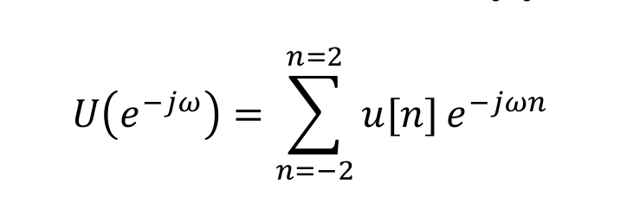

Find **Energy Spectral Density** (ESD) is computed as:

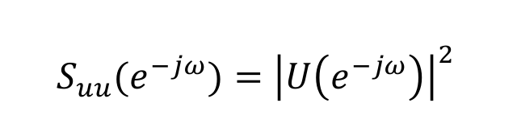

where ω ranges from -2π to 2π.

**Plot magnitude and phase of U($e^{-jw}$) and *ESD***

* 1. ***Source Code for Task-1***

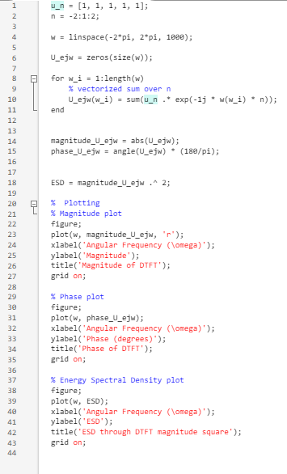

* 1. ***Results and Discussions for Task-1***

1. *Magnitude and phase of U($e^{-jw}$):*

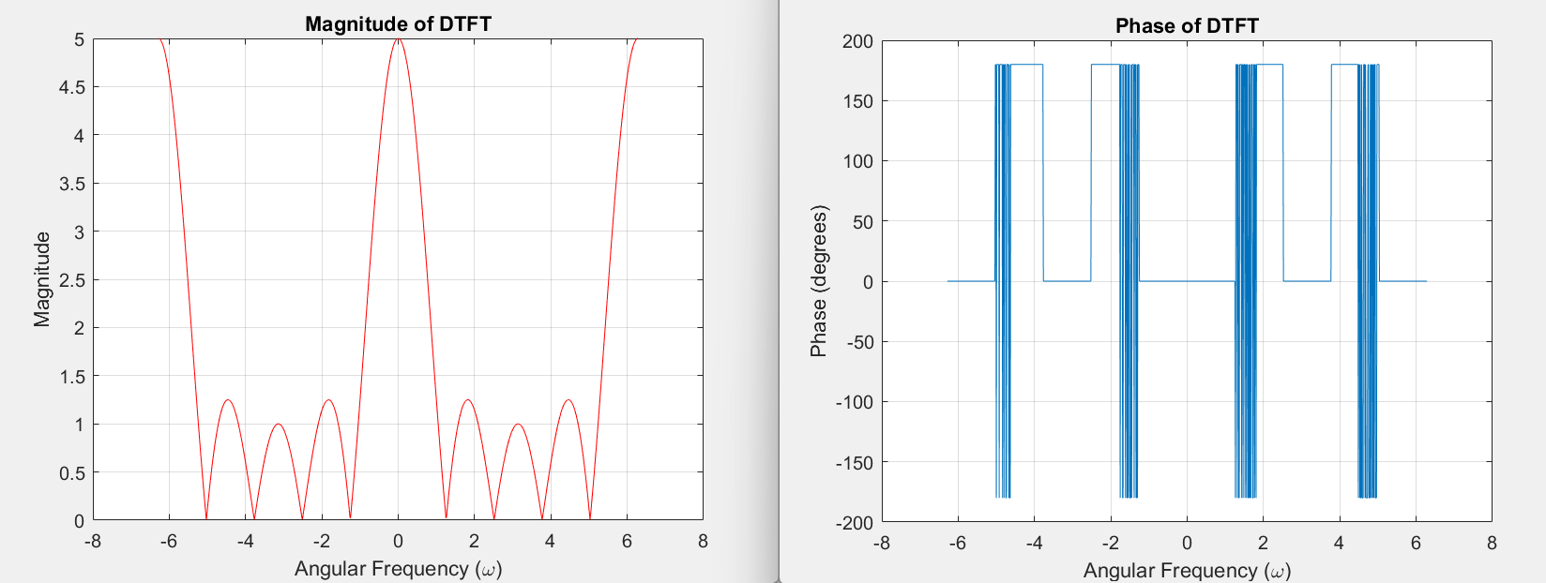

1. *Plot of ESD:*

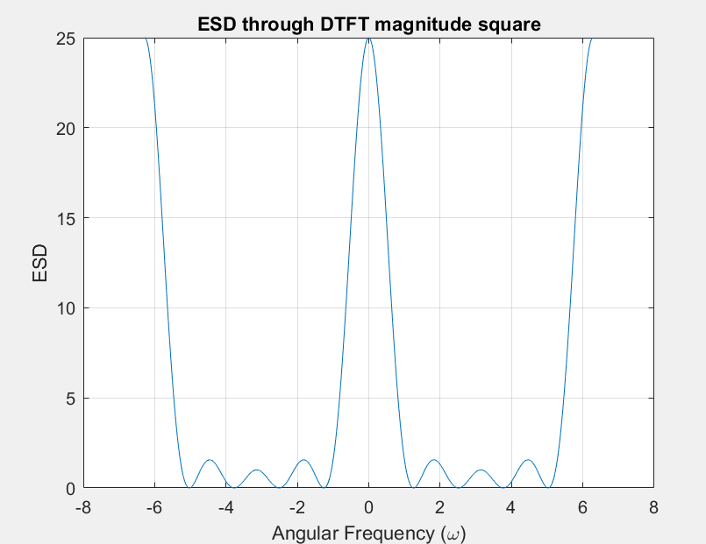

*From –π to π, the strongest spectral component of u[n] is at ω = 0, which can be seen from the amplitude graph of its DTFT and that of its ESD.*

1. **Task-2**
   1. ***Description of Task-2***

Find the autocorrelation 𝑅𝑢𝑢 of above 𝑢[𝑛] by using your own code. Find DTFT of 𝑅𝑢𝑢 and verify that it is equivalent to 𝑆𝑢𝑢(𝑒−𝑗𝜔).

* 1. ***Source Code for Task-2***

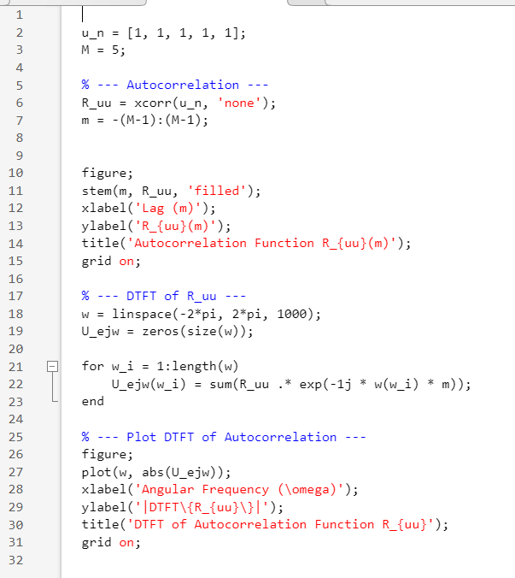

* 1. ***Results and Discussions for Task-2***

1. *Autocorrelation of u[n]*

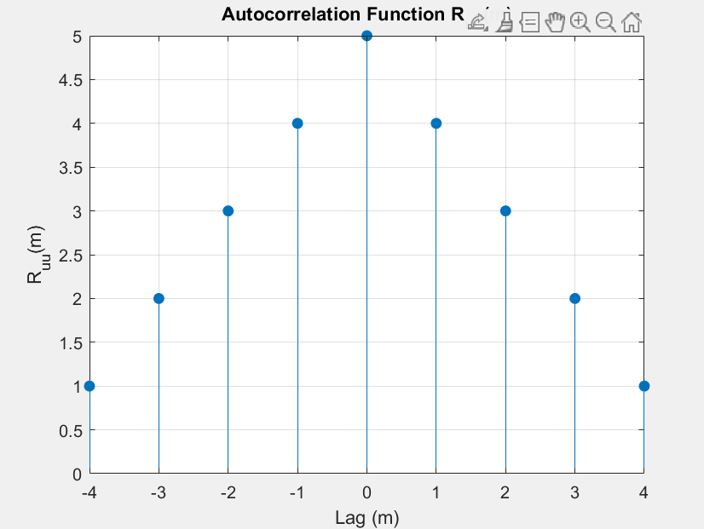

1. *DTFT of Ruu*

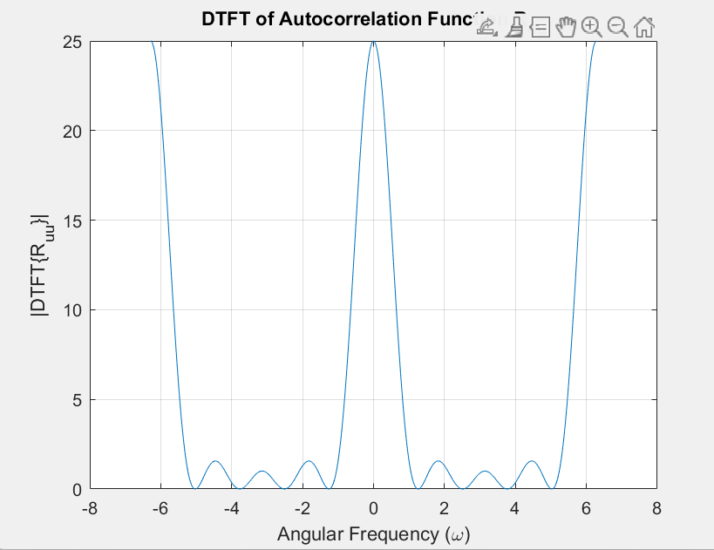

The ESD obtained in Task-1 matches the DTFT of the autocorrelation computed in Task-2. This confirms the Wiener–Khinchin theorem, which states that the energy spectral density of an energy signal is equal to the Fourier transform of its autocorrelation.

1. **Conclusion**

In this experiment, the DTFT of a finite rectangular pulse was computed and its Energy Spectral Density (ESD) was obtained from the magnitude-squared of the DTFT. The autocorrelation of the same signal was then calculated and its DTFT was taken. The resulting spectrum matched the ESD obtained earlier. This verified the Wiener–Khinchin theorem, demonstrating that the ESD of an energy signal is equal to the Fourier transform of its autocorrelation. Through this, the theoretical relationship between time-domain correlation and frequency-domain energy distribution was successfully confirmed.

**Rubrics for Experiment No.**

|  |  |  |  |  |
| --- | --- | --- | --- | --- |
| **Performance** | **Exceeds expectation (2)** | **Meets expectation (1)** | **Does not meet expectation (0.5)** | **Marks** |
| **R1:** Knowledge of required functions for code design.  **Marks: 0-2** | Has required knowledge for code | Has partial knowledge for code | Has no knowledge for code |  |
| **R2:** Simulation of experiment **Marks: 0-2** | Simulates all the tasks correctly by himself | Needs guidance to simulate the tasks correctly | Incapable to simulate the tasks correctly by himself even with  guidance |  |
| **R3:** Demonstrate proper results with justification  **Marks: 0-2** | Correct results are provided with required  justification | Results are provided with minor errors and/or with little  justification | Results are provided with major errors and/or with no  justification |  |

**Rubrics for Lab Manual No.**

|  |  |  |  |  |
| --- | --- | --- | --- | --- |
| **Performance** | **Exceeds expectation (0.5)/(0.25)** | **Meets expectation (-)/(-)** | **Does not meet expectation**  **(0)/(0)** | **Marks** |
| **R1:** Timely submission  **Marks: 0-0.5** | The submission is on  time | --- | Late submission |  |
| **R2:** Report completeness  **Marks: 0-0.25** | All relevant calculations,  specifications, code, graphs, and results are provided with proper explanation. | All the relevant calculations,  specifications, code, graphs and results  are provided but with little  explanation and justification. | Most of the relevant graphs, results, calculations,  specifications, and code are missing, as well as  their proper explanation and justification is also missing. |  |
| **R3:** Error-free writeup  **Marks: 0-0.25** | The submitted assignment is without any  plagiarism and formatting errors. | Some parts of the submitted  assignment contain formatting errors and plagiarized material. | The submitted  assignment is mostly plagiarized and contain formatting errors. |  |